MMEA East Central District #7
14th annual Honor Choir

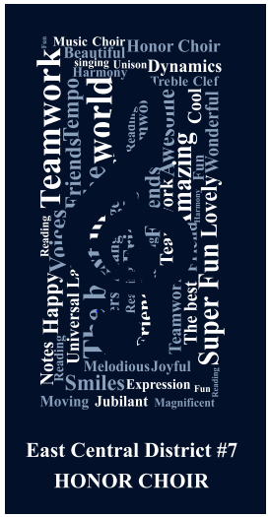

Welcome to MMEA East Central District #7. I hope you all had a nice Holiday break. Registration is open for our 14th annual Elementary Honor choir.

Registration here: http://www.ec7mmea.org/elementary-music.html Last day for registration is March 23 I will get an invoice to you for PO as soon as you register.

All information is on our webpage, or on our facebook page: East Central #7 MMEA.

MUSIC: 10% discount from Midwest Sheet Music. They have music is stock and ready to ship to you! Info on the ECD #7 Website or attached letter.

Honor choir T shirts: Order form attached for your students and you to keep track. A google form is on the website to fill out for qty to order for me DUE: March 23

It is so difficult to keep track of all the elementary music teachers in our district, so please let me know of someone that was left off of the list. I am doing the best I can to keep you informed of information in our district. I know I probably have missed something, but will get things to you as you register or when I hear from you.

Contact Info: If you haven’t heard from me feel free to contact me with one of the following ways below. phone/text/facebook/email
636-667-3965 =home 636-583-7744=school
baers@unionrxi.org = school
yoderbaer@gmail.com = personal
Sheila Yoder Baer = fb
I’m not so good at twitter and instagram, but if someone wants to tutor me I’d love it (I think).

I look forward to seeing you at MMEA the end of this month as well as in April for Honor Choir. My kids are excited and I hope yours are as well.

Musically,

Sheila Yoder Baer
VP Elementary ECD#7

