EAST CENTRAL TREBLE CHOIR FESTIVAL
Featuring Kim Warger, Clinician
2017 CHOIR REGISTRATION FORM

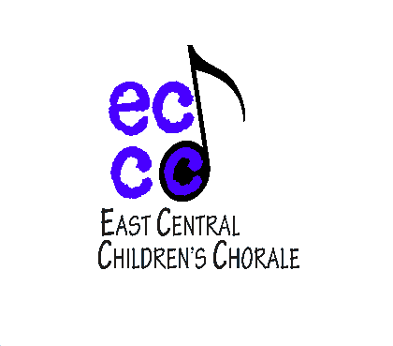
Registration form and check or purchase order, or purchase order number, must be returned no later than October 27, 2017. Registration is $80 and includes performance, clinic, written evaluation, and audio recordings. Checks and purchase orders should be made payable to East Central College. Each group is allotted 30 minutes for warm-up and 30 minutes for performance and clinic. Please provide one musical score for clinician.

DIRECTOR’S NAME: __________________________ ACCOMPANIST NAME: ________________________
DIRECTOR’S PHONE NUMBER: __________________ DIRECTOR’S EMAIL ADDRESS: ___________________
SCHOOL NAME: ______________________________
GRADE OF CHOIR: _______ NUMBER OF SINGERS: ______ SPECIAL SET UP REQUIRED: ______________
NAME OF SELECTIONS: 1) ____________________________ COMPOSER __________________________
2) ____________________________ COMPOSER __________________________
SCHEDULING PREFERENCE (for schools bringing more than one group):
Back-to-Back Times Time between

(overlapping warm-up and performance times) (for groups with only one director)

TIME PREFERENCE*:
Early Morning (9a.m. - 11 a.m.) Late Morning (11 a.m. - 1 p.m.)
*Times are assigned on a first-come, first-served basis. We will do our best to accommodate your preference.

Send the completed form with check or purchase order payable to East Central College in the amount of $80 to:

East Central College
ATTN: Dr. Timothy Sexton
1964 Prairie Dell
Union, MO 63084
*Receipts can be picked up the day of the event.

